ODD AND EVEN NUMBERS
A. Colour the apples with odd numbers green and with even numbers red.

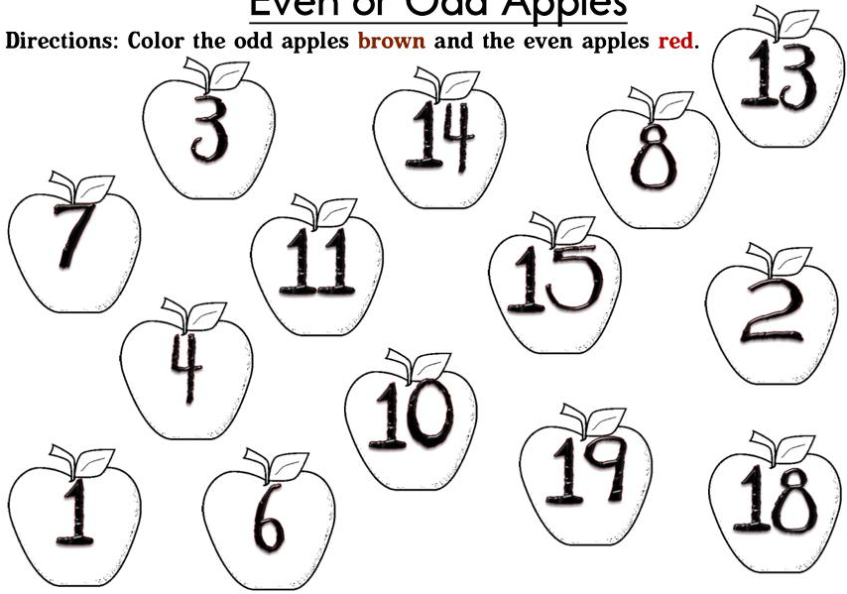
80
66
70
99
51
42
25
77
58
54
83
97
52
23
____________________________________________________________
ADDITION AND SUBTRACTION
B. Write H, T and O at appropriate places and then solve the given sums.
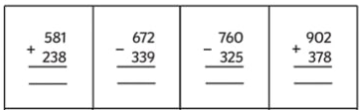
1
MULTIPLICATION
C. Fill in the missing numbers to complete the following.
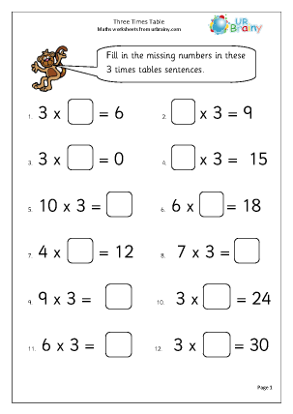
a

b

c

d

e

f

g.

h

i

j

k

l

_____________________________________________________________
JUST FOR FUN
Fill in the missing numbers in the blank boxes. One has been done for you.
