NAME:______________ CLASS: II SEC:______________________ English
LAKSHMIPAT SINGHANIA ACADEMY(2020-2021)
Topic: Countable and Uncountable Nouns, Is/Are
Last Date of Submission: 25th July, 2020
Assignment No: 15
Label the given pictures. Write ‘C’ for countable nouns and ‘U’ for uncountable nouns as shown in the example. You may use the help box given below:


eg.  water--U |     1  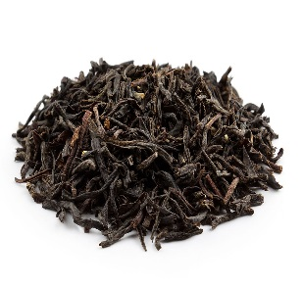    ________________--- ____ | 2.  ________________--- ____ |   3.  ________________--- ____
  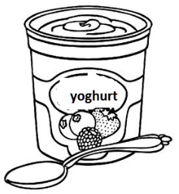  4.  ________________--- ____ | 5.  ________________--- ____ | 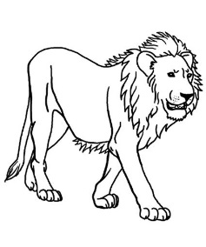  6.  ________________--- ____ | 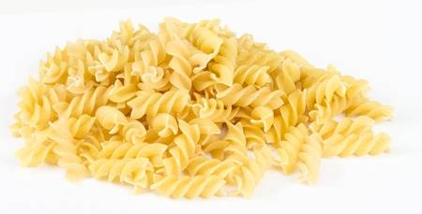  7.  ________________--- ____
Help box: pasta soil tea newspapers lion pencils umbrella

LAKSHMIPAT SINGHANIA ACADEMY
NAME:______________ CLASS: II SEC:______________________ English
Is/Are
Look at the given picture and make five sentences using is or are:

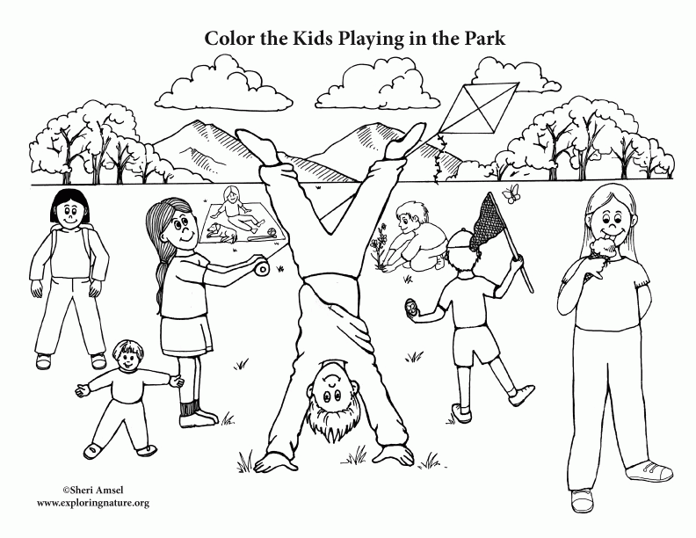

Help box:pasta soil teanewspapers lion pencils umbrella

