LAKSHMIPAT SINGHANIA ACADEMY
2020-2021
Name: _______ Class: Montessori - __ Date: ___________

Introduction to number 2

Colour the mangoes.


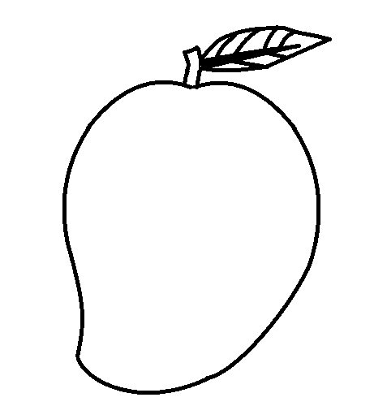

2 mangoes

