NAME:______________ CLASS: II SEC:______________________ English
LAKSHMIPAT SINGHANIA ACADEMY(2020-2021)
Topic: Countable and Uncountable Nouns, Is/Are
Last Date of Submission: 25th July, 2020
Assignment No: 15
Label the given pictures. Write ‘C’ for countable nouns and ‘U’ for uncountable nouns as shown in the example. You may use the help box given below:


eg.  water--U |     1  newspapers - C  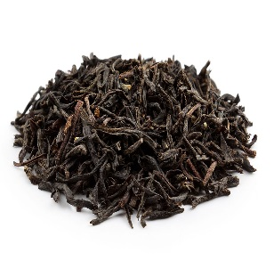   | 2.  umbrella - C |   3.  soil-U
    4.  pencils - C | 5.  tea- U | 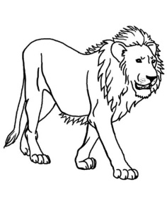  6.  lion - C | 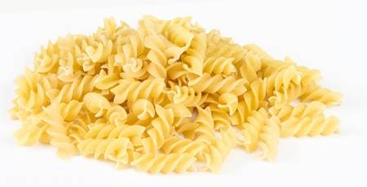  7.  pasta – U
Help box: pasta soil tea newspapers lion pencils umbrella

LAKSHMIPAT SINGHANIA ACADEMY
NAME:______________ CLASS: II SEC:______________________ English
Is/Are
Look at the given picture and make five sentences using is or are:

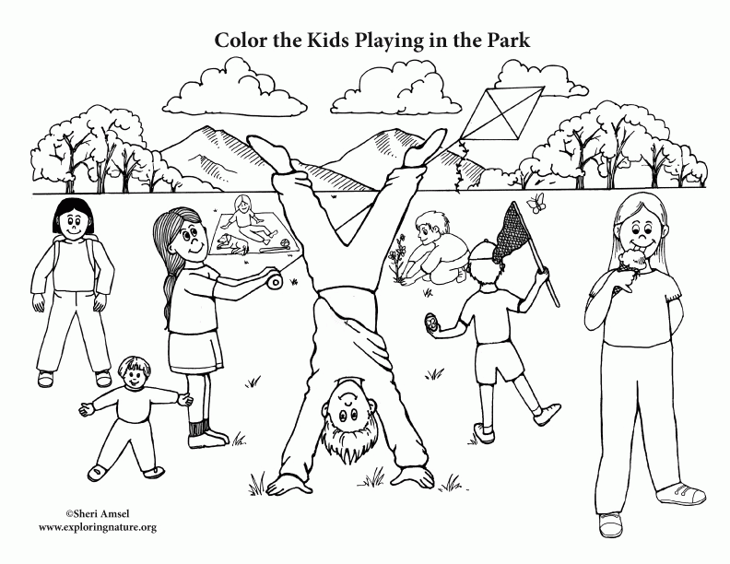
- A girl is flying a kite.
Help box:pasta soil teanewspapers lion pencils umbrella
- There are many trees in the park.
- Another girl is licking an ice cream.
- A boy is planting a sapling.
- The clouds are sailing in the sky.

